**POKHARA UNIVERSITY**

**UNITED TECHNICAL COLLEGE**

**DEPARTMENT OF COMPUTER ENGINEERING**



A

MINOR PROJECT PROPOSAL REPORT ON

“HEALTH CARE APPOINTMENT BOOKING SYSTEM”

(As partial fulfillment of B.E in Computer Engineering)

[Code no.: CMP 290]

# **COVER PAGE**

Submitted by:

Bibek Poudel [BEC-2019-04]

Kushal Duwadi [BEC-2019-11]

Kritika Shrestha [BEC-2019-10]

Smriti Kafle [BEC-2019-24]

Paras Poudel [BEC-2019-13]

Submitted to:

Department of Computer Engineering

May-2022

# **ABSTRACT**

# **TABLE OF CONTENT**

**COVER PAGE** i

**ABSTRACT** ii

**TABLE OF CONTENT** iii

**LIST OF FIGURES** iv

**LIST OF TABLES** v

**LIST OF ABBREVINATION AND ACRONYM** vi

**Chapter 1: Introduction** 1

1.1 Background 1

1.2 Statement of Problem 1

1.3 Objective 2

1.4 Application 2

1.5 Flow Diagram Of Project 3

**Chapter 2: LITERATURE REVIEW** 4

2.1 Introduction 4

2.2 Review of literature 4

2.3 Case Study 5

**Chapter 3: Methodology** 6

3.1 Software Used 6

3.3. Database Management: 8

**Chapter 4: Time Estimation** 11

**Chapter 5: Expected Outcome** 13

**Reference:** 14

# **LIST OF FIGURES**

Figure A.1.1: System flow diagram of project 3

Figure B3.1: Different states of the Waterfall Model 8

Figure C3.2: ER Diagram 10

Figure D 4.1: Gantt Chart 12

# **LIST OF TABLES**

Table 3.1 Login Information……………………………………………………………………....9

Table 3.2 Patients Data……………………………………………………………………………9

# **LIST OF ABBREVINATION AND ACRONYM**

BEC: Bachelor of engineering in computer

PU: Pokhara University

SDLC: Software Development Life Cycle

DBMS; DataBase Management System

ERD: Entity-Relationship Diagram

GUI: Graphical User Interference

CGI: Common Gateway Interface

# **Chapter 1: Introduction**

## 1.1 Background

Healthcare booking system is a web based computerized system that provides a platform for hospitals, clinics and other health services providing organizations to manage hospital facilities through online medium. It provides online appointment with doctors of representative hospitals and clinics as well as it provides online booking of cabins and other facilities which are physically provided by respective hospitals and clinics. It also provides online health care services as well as appointment for home visit can be booked with the help of this platform.

Healthcare booking system has a main motive to make routine check-up and interaction with their doctors easier. It is mainly focused to provide the best facilities to each and every patients. This web based design will make easier to subscribe the package and further expansion on package will be possible with less effort. This project will take over the general task responsible by receptionist. In this rapidly growing world it is really hard to stand as a business without the use of latest technologies. Thus, this project will help the management system to be easier.

This system can be used by a non-programming/technical personal avoiding the human handled errors. This project can be used by two users:

1. Patients/Normal users

2. Hospitals and Clinics

Patients/Normal users have the free functionality for registering and making payment for the appointment. These users can only have limited rights to this system. These users cannot delete or add any offers or publish any official or unofficial functions linking to organizational administration.

Hospitals and Clinics have the access to control the official package/offers or to add/delete/update information the doctors or the facilities available.

## 1.2 Statement of Problem

In this present situation where all the facilities are provided by the electronic means hospital facility should also be in the top most for providing facilities with less interaction with the peoples. Patients have to wait for the long procedure in hospital for the appointment and many wishes for having a private cabin inside hospital but due to the limited options it is a hard job. The most common problem of paper based reservation of appointment and other facilities are:

i.Hard to find the old Data

ii.Time consuming for reservation and appointment

iii. Data duplication and Over Reservation

## 1.3 Objective

Our project on Health Care Appointment Booking System is being developed to provide online consultation to the patients with much more effective services. The following are the objectives of this project:

* To create web based online doctor appointment management system.
* To manage information related to all patients.
* To provide emergency information in critical situations.
* To facilitate users for unrelated services.
* To optimize the available resources and to make reminders/cancellations/reschedules easily and also delivers a premium experiences.
* To improve the quality of patients care and patients satisfactions.

To reduce the waiting time of the patients and select the appointment time according to his/her preference.

## 1.4 Application

Our project can be implemented in several application areas for different purposes. Although our project won't have all the features required to be a good hospital management system, it will still manage to handle most important system which is taking appointment/reservations. The hospital and clinics will also have access and manage the following features:

i. Patients database management

It can manage or maintain the patient records and provide discounts and offer for the user who have visited the site.

ii. Cabin and Appointment Availability

The user can check whether the appointment or other facilities provided by hospital are available or not.

iii. Reservation

By using it reservation of appointment and other facilities can be done avoiding the overwriting/overbooking.

iv. Search all previous patient's data

Through using this system, admin will be able to search for the previous data of patients.

## 1.5 Flow Diagram Of Project



Figure .1.1: System flow diagram of project

# **Chapter 2: LITERATURE REVIEW**

## 2.1 Introduction

The literature review section of this purposal report focuses on the observations and conclusions made as per the several research papers that we went through related different case studies and other things related to our approach. An online clinical appointment is a web utility that permits the patients to book schedule via online registration. A best convenience way that logging on is a simple way of lifestyles. It is tough to obtain appointments via way of means of direct contact to the hospital and lineup in an exceedingly queue. The maximum idea of this task is to induce schedule via online utility which solves the issues to the patients. It is a solution for the doctors and patients as a result they can schedule their own time. A lot of research has been done for this project by our team on online doctor's appointment and booking and here are some of the study's results:

## 2.2 Review of literature

Patients can look for doctor availability by looking at their profile. online services are aexperiencing spectacular growth especially in the realm of health. With the swift development in technology, the application and demand of digital product and services are increasingly growing. So, online health services are being preferred that are facilitating people to address their health issues and reap multiple benefits by adopting it. . Online health facilities is an emerging concept in Nepalese context so, information couldn’t be collected from multiple sources due to lack of awareness.[1]

Doctors on call Nepal is one of the most helpful team in Nepal. With the pandemic making it hard to access hospitals, doctor on call has made it easier for people like us to easily access services like doctor consultation, blood test, pcr test and many more.[3] The Internet has recently emerged as another means to make appointments. Online doctor appointment scheduling has been a popular research topic. Several studies conducted satisfaction surveys and found that online doctor appointment scheduling is an extremely important feature, and most patients would use the service again .

In these method the patients need not to go hospital for booking. The patients only need internet for booking purposes and hospital individual doesn’t have direct contact while booking. Both of them can adjust their schedule time through online. The system get rid of the issues appeared during traditional booking system. This system provides a clear understanding of online schedule of patients coming to the hospital. This review is helpful for the researcher working in this field.

## 2.3 Case Study

1.Hamro Doctor

-> Hamro Doctor is a well managed online consulting website which provides patient to have a virtual routine consultation with the top doctors by charging its own rate types.  Objectives of HamroDoctor. HamroDoctor is the first health portal of Nepal that has aimed at making health services accessible to every individual. The unabridged database of doctors, hospitals, ambulance and so on have made HamroDoctor one of the reputed brands for doctors, patients, hospitals, and government. It's a virtual based website which can provide appointment for online consultant and few of the physical appointment based on Kathmandu area only.[1]

2.Clinic one

-> Clinic one is also a well-managed online consulting website but with limited features on it and only limited Health consultant can be found in this site and is completely online consultant based. It's also a Kathmandu based website.[2]

3.Doctors on call

-> Doctors on Call Nepal is constantly working in making health care accessible, affordable & equitably available via means of providing home based care services and digital health care services: strengthening health care delivery eco system.Doctors on call provides many features like home facility of doctor visit, physiotherapy at home, nursing care at home, laboratory test at home and so on. It's also a Kathmandu based website.[3]

4.Mero Doctor

-> Mero Doctor is most advance feature having web-based system providing data and names of doctors of different working on different shift on different hospital making the appointment service easy to book and for the reservation this web-based system is most popular in its field.[4]

# **Chapter 3: Methodology**

## 3.1 Software Used

3.1.1 VS Code (Visual Studio Code)

->Visual Studio Code is a lightweight but powerful source code editor which runs on your desktop and is available for Windows, macOS and Linux. It comes with built-in support for JavaScript, TypeScript and Node.js and has a rich ecosystem of extensions for other languages (such as C++, C#, Java, Python, PHP, Go) and runtimes (such as .NET and Unity). The main features of this software are:

Emmet Abbreviations: These useful shortcuts come built-in to VS Code, and they make writing HTML (and CSS) a lot faster.

The Integrated CLI (Command Line Interface): To save switching between windows, VS Code offers an integrated terminal or CLI. Simply, press CNTRL + ' or CMD + ' to open it up, and the same command to close it. It will automatically open in the directory you have open in VS Code, which saves the navigation step required for operations in a standard terminal.

ESLint: ESLint is a powerful and popular linting tool, which helps you spot errors in your code and fix them as you write and which helps you follow common best-practices. It’s also a great learning tool, since researching ESLint errors has taught me many best practices I didn’t know before, and it’s helped me understand why they are best practices.

Prettier: Prettier is an opinionated code-formatter. It prescribes a certain formatting style as the correct one, but its popularity is making its rules something of an established standard for JavaScript, CSS, and increasing numbers of other languages.

Multi-Cursor Shortcuts: The ability to edit with multiple cursors can be a huge time saver. To use this most effectively requires memorization of a handful of commands, but they’ll soon become second nature.

Text Wrap: There aren’t many cases where I’d prefer my text to run off the screen, forcing me to use the dreaded horizontal scroll. To toggle wrapping on or off on a per-file basis, simply press ALT + Z

Execute and Debug JavaScript: The best choice for debugging JavaScript within VS Code is Microsoft’s own “Debugger for Chrome” extension. How it works can be a little complex, so I recommend you take a look at the official documentation if you want to learn more. Suffice to say that this is a powerful tool, and it was a real eye-opener for me when I discovered it — it will take you a lot further than console.log() !

3.1.2 XAMPP

XAMPP stands for Cross-Platform (X), Apache (A), MariaDB (M), PHP (P) and Perl (P). Since XAMPP is simple, lightweight Apache distribution it is extremely easy for developers to create a local web server for testing and deployment purposes. Everything you needed is to set up a web server – server application (Apache), database (MariaDB), and scripting language (PHP). XAMPP works equally well on Linux, Mac, and Windows. Its features are:

XAMPP has been designed to be the easiest way to install and run a development server. There are numerous other WAMP packages available, but XAMPP is one of the most complete on offer. In addition to Apache, MySQL, and PHP, XAMPP includes other really useful tools such as the phpMyAdmin database administration tool, FileZilla FTP server, Mercury mail server, Perl programming language, and JSP server Tomcat.

XAMPP can also install an administration site as the home page of the server. From which you can undertake all manner of administrative tasks, such as checking the server status and security, launch tools like phpMyAdmin and Webalizer analytics.

3.2 Database Management

3.2.1. SDLC

Waterfall approach was first SDLC Model to be used widely in Software Engineering to

ensure success of the project. In "The Waterfall" approach, the whole process of software development is divided into separate phases.

Since water fall method is one of the simplest methods to develop any small as well as large software package, we will be using water flow method to develop our project as well. Water flow method allows us to clearly see what requirements are and to develop software according to requirements. While using water fall method. Water fall methods forces us to develop our software step by step as also mentioned in Work Schedule. The following illustration is a representation of the different states of the Waterfall Model.[6]



Figure B3.1: Different states of the Waterfall Model

## 3.3. Database Management:

The database management system (DBMS) is the software that interacts with end users, applications, and the database itself to capture and analyze the data. The DBMS software additionally encompasses the core facilities provided to administer the database. The sum total of the database, the DBMS and the associated applications can be referred to as a "database system". Often the term "database" is also used to loosely refer to any of the DBMS, the database system or an application associated with the database.

Since database is an organized collection of data,the data is typically organized to model relevant aspects of reality, in a way that supports processes requiring this information. For this software, we will be using mySQL as our database management tool. Database management systems are specially designed applications that interact with the user, other applications, and the database itself to capture and analyze data. Database management comprises a number of proactive techniques to prevent the deleterious effects of data growth.

3.3.1 Data Collection and management

Table 3.1 Login Information

|  |  |  |
| --- | --- | --- |
| **Attribute Name** | **Data Type** | **Attribute Type** |
| Username | Username ID | varchar(10) |
| Password | Password | varchar(10) |

Table 3.2 Patients Data

|  |  |  |
| --- | --- | --- |
| **Attribute Name** | **Data Type** | **Attribute Type** |
| Name | Patient’s name | varchar(10) |
| Age | Patient’s age | int |
| Contact | Patient’s contact | int |
| Address | Patient’s address | varchar(10) |
| Health Issue | Patient’s issue | Varchar(10) |
| Date For Appointment | Patient’s date for appointment | date |

3.2.4 ER Diagram

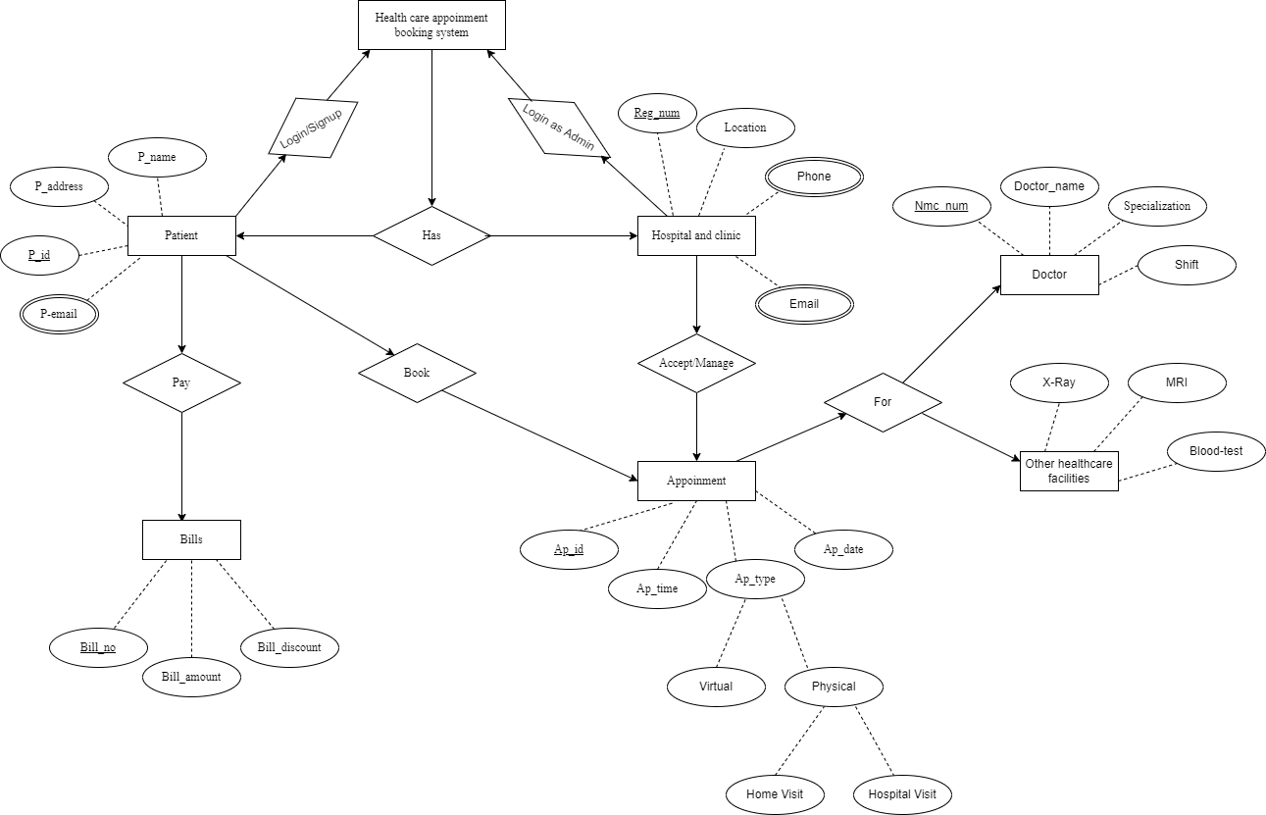

Figure C3.2: ER Diagram

# **Chapter 4: Time Estimation**

Before getting started with any project we have to prepare a working schedule consisting of several topics that we would be working on throughout the project development phase. We will try to balance between learning how code works and by researching necessary details about our project.

* Week 1-2: At the beginning of the project development, we will begin with research on different programming tools that will be used throughout the project. We will also begin preparing documentation during this time and keep updating information in it followed by our progress in the upcoming weeks for the project. And we will also consult with different doctors and health workers about our project for their suggestion.
* Week 3-5: In the starting of third week, we will mainly focus on actual coding and use interface designing. Within the period of third week, we will finish our user interface designing as well as some major programming related to actual software and database management. We will also keep testing and monitoring our application during the fifth week for any issue related with portability and performance.
* Week 6-8: When the sixth week is about to start, we will start focusing on the operation, integration and deployment part along with continuous development phase. The testing phase would still go on till the end of 8th week along with deployment operation and monitoring.
* Week 9-10: This is the phase where we would be focusing mainly on the preparation of final project report and presentation along with all the documentations started during the beginning of the project development phase. Finally, at the end of 10th week we will complete our final project report and submit it to the respective department.

Figure D 4.1: Gantt Chart

# **Chapter 5: Expected Outcome**

Since, our project is platform for health service provides and the health service receiver(patients) we have consult with many health service providers and many health workers from their review we have expected to be top most online site providing facilities to the consumers. We will be shorting the distance between the lengthy paperwork or queue problems for booking and appointment. This platform is developed to reduce the health problem caused due to the unmanaged old paper based system with a minimal error.

# **Reference:**

1.Hamro Doctor "<https://www.hamrodoctor.com/>"

2.Clinics One "<https://www.clinicone.com.np/online-consultation-in-nepal/>"

3.Doctors on Call "<https://doctorsoncall.com.np/appointment/>"

4.Mero Doctor "<https://www.merodoctor.com/doctors/finddoctors?dep=true>"

5.VScode "<https://bretcameron.medium.com/7-essential-features-of-visual-studio-code-for-web-developers-be77e235bf62>"

6. Unknown, “java” <https://en.wikipedia.org/wiki/Java>, unknown